MyEd BC Course Code requests – instructions and form Revised: Aug 2020
Please read these instructions before submitting the form in a Web Help Desk ticket.
- Use the ministry course registry to complete this form. The url is http://www.bced.gov.bc.ca/datacollections/course_registry_web_search/
- Check the MyEd District catalogue to see if the course is already available.
School View > Schedule TT > Courses ST > Options > Add (set School Level filter = All, to see all available courses)
- If the course or flavor of the course you need is not in the MyEd District catalogue, complete all fields with the one exception (the shaded field) labeled SIS course code.
  - School year: The school year the student will be given 4 credits for course completion. Remember the school year date is based on the June date. Check the Course open and close date on the ministry course registry
  - SIS Course Code: Do not enter. The course code will be filled out by the district user creating the code.
  - Course Title: The title must be correctly spelt for it will be used to display on the course code.
  - Ministry Code: The TRAX or the MyEd course code must be entered here so we are correctly mapping the codes.
  - Course Category: For Board/Authority Approved (BAA) courses only, the course category must be identified before the course code can be created. Only the BAA courses that were approved by SD61 will be available to add to school course catalogue. Please see the complete list of SD61 BAA courses managed by the District Learning Team. Before a course code is created, this list will be referenced to confirm that the requested course has been approved by the board for use; please confirm this prior to submitting a course code request.
  - Grade Level: The grade level will be identified on the ministry course registry. If you are requiring a grade 11 course and it is a BAA course, please specify the diploma category as Fine Arts or Applied Skills.
  - Number of Credits: The credits earned for any student taking the course in your school.
  - Department: The department specified will be used to create the code but once it is added to the school course catalogue, the department can be reassigned.
The following fields have been auto-filled to NO, but can be changed when you complete the form.
  - Hide on Transcript: Yes it should be hidden or No it should be visible. This can also be changed on individual student transcript records.
  - Hide on Report Card: Yes it should be hidden or No it should be visible. This can also be changed on individual student transcript records.
  - Hide on Grade Input: Yes it should be hidden or No it should be visible. This can also be changed on individual student transcript records.
  - Include in GPA: Yes it should be included or No it should be excluded. This can also be changed on individual student transcript records.
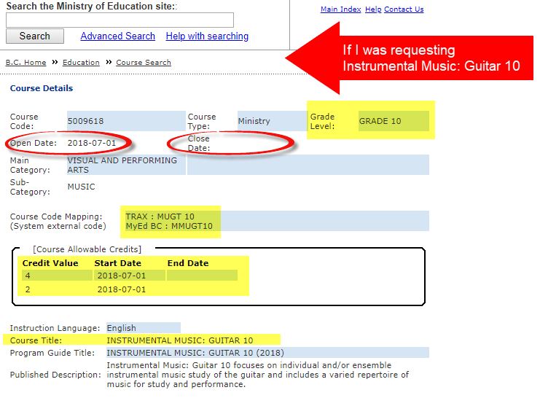
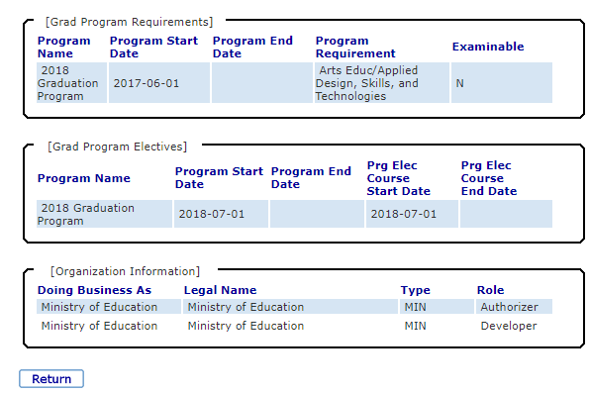
MyEd Course Code Request Form
To request a new SIS Course code, the requestor (e.g., the school, program coordinator, Student Services, etc.) must provide the information below for the course to be added to the MyEd BC District Course Code Catalogue. It is important that this information be accurate and complete. You may request up to 3 course codes using this one form.
- Submission: Save this form as a Word document and send the completed copy as an attachment to a Web HelpDesk ticket. https://webhelpdesk.sd61.bc.ca/
- Confirmation of completion: Upon completion of course addition to the MyEd BC District Course Code Catalogue, the new code will be added to the notes of the web helpdesk ticket for your reference.
School year
(e.g., 2022-2023)
SIS Course Code (ITL use only)
Course title:

Ministry Code
(TRAX or MyEd
n/a for BAA courses)
Course Category
(BAA only)
Grade Level
Diploma Category (BAA only - for grade 11 BAA, specify FA or AS)
Number of Credits

Department

Hide on Transcript | NO | NO | NO
Hide on report card | NO | NO | NO
Hide on grade input | NO | NO | NO
Include in GPA | YES | YES | YES

